1) Which of these numbers is prime? 9, 15, 53, 56, 85
2) For each pair of integers, find the greatest common factor (GCF) between them.
a) 36 and 60 b) 45 and 126
c) 50 and 90 d) 20 and 140
3) Find the greatest common factor of 110, 40 and 120.

4) Find the greatest common factor of 44, 12, and 28.
5) What is the least common multiple of 8 and 10? Another way to say this is: LCM (8, 10) =?

6) What is the least common multiple of 11 and 7? Another way to say this is: LCM (11, 7) =?

7) Abe is going to plant 54 oak trees and 27 pine trees. Abe would like to plant the trees in rows that all have the same number of trees and are made up of only one type of tree.
What is the greatest number of trees Abe can have in each row?

Trees
- Enzo and Beatriz are playing games at their local arcade. Incredibly, Enzo wins 5 tickets from every game, and Beatriz wins 11 tickets from every game. When they stopped playing games, Enzo and Beatriz had won the same number of total tickets.
What is the minimum number of games that Enzo could have played?

Games

- There are 72 boys and 90 girls on the math team. For the next math competition, Mr. Johnson would like to arrange all of the students in equal rows with only girls or only boys in each row. What is the greatest number of students that can be in each row?

Students
BONUS PROBLEMS
- Yadira's mom is buying hot dogs and hot dog buns for the family barbeque. Hot dogs come in packs of 12 and hot dog buns come in packs of 9. The store does not sell parts of a pack and Yadira's mom wants the same number of hot dogs as hot dog buns.
What is the smallest total number of hot dogs that Yadira's mom can purchase?

Hotdogs
- Ronald and Tim both did their laundry today. Ronald does laundry every 6 days and Tim does laundry every 9 days. How many days will it be until Ronald and Tim both do laundry on the same day again?

Days
- Sherman goes golfing every 6th day and Brad goes golfing every 7th day. If Sherman and Brad both went golfing today, how many days until they will go golfing on the same day again?

Days

- Find the area of the shape shown below. Square Units​​

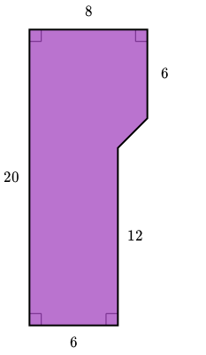

SOLUTIONS
- A prime number has exactly two factors: 1 and itself.
The factors of 9 are 1, 3, and 9.
The factors of 15 are 1, 3, 5, and 15.
The factors of 53 are 1 and 53.
The factors of 56 are 1, 2, 4, 7, 8, 14, 28, and 56.
The factors of 85 are 1, 5, 17, and 85.
Thus, 53 is a prime number.

a) 36 and 60  36 = 2 x 2 x 3 x 3  60 = 2 x 2 x 3 x 5  GCF = 2 x 2 x 3 = 12 | b) 45 and 126  45 = 3 x 3 x 5  126 = 2 x 3 x x3 x 7  GCF = 3 x 3 = 9
c) 50 and 90  50 = 2 x 5 x5  90 = 2 x 3 x 3 x 5  GCF = 2 x 5 = 10 | d) 20 and 140  20 = 2 x 2 x 5  140 = 2 x 2 x 5 x 7  GCF = 2 x 2 x 5 = 20

- The greatest common factor (GCF) is the largest number that is a factor of 110, 40, and 120.
In order to find the GCF, we can factor each number completely as a product of prime numbers:
110 = 2 x 5 x11
40 = 2 x 2 x 2 x 5
120 = 2 x 2 x 2 x 3 x 5
Now, let's find the factors that are common to each number:
110 = 2 x 5 x 11
40 = 2 x 2 x 2 x 5
120 = 2 x 2 x 2 x 3 x 5
Each number shares the factors 2 and 5 so the GCF is 2 x 5=10
The greatest common factor of 110, 40, and 120 is 10.
- The greatest common factor (GCF) is the largest number that is a factor of 44, 12, and 28.

In order to find the GCF, we can factor each number completely as a product of prime numbers:

44 =2 x 2 x 11 12 =2 x 2 x 3 28 = 2⋅2⋅7
Now, let's find the factors that are common to each number:
44 =2 x 2 x 11 12 =2 x 2 x 3 28 =2 x 2 x 7
Each number shares the factors 2 and 2 the GCF is 2⋅2=4
The greatest common factor of 44, 12, and 28 is 44.

- The least common multiple is the smallest number that is a multiple of 8 and 10.
We know that 8×10 or 80 is a common multiple, but is it the least common multiple?
Write out the multiples of 10 until we find a number divisible by 8.
10, 20, 30, 40
So, the least common multiple of 8 and 10 is 40.

- The least common multiple is the smallest number that is a multiple of 11 and 7.
We know that 11×7 or 77 is a common multiple, but is it the least common multiple?
Write out the multiples of 11 until we find a number divisible by 7.
11, 22, 33, 44, 55, 66, 77
So, the least common multiple of 11 and 7 is 77.

- To find the greatest number of trees, we want to find the greatest common factor of 54 and 27.
To do so, let's find factors of 54 and 27.
54: | 1,2,3,6,9,18,27,54
27: | 1,3,9,27
The greatest common factor of 54 and 27 is 27.

- Let's look at their individual ticket totals after their first few games.
Every time Enzo plays, he wins an additional 5 tickets.
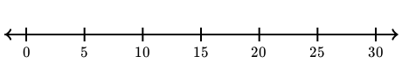
Every time Beatriz plays, she wins an additional 11 tickets.
Their ticket totals are not the same yet, they must have played more games!

When we keep going, we see that the multiples first meet at 55.
Enzo
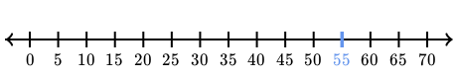
Beatriz
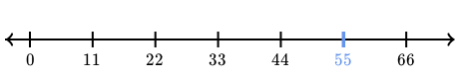
Mathematically, we say that 55 is the least common multiple of 55 and 11. In math notation this looks like: LCM (5, 11) = 55
To find the number of games Enzo played, we need to divide by how many tickets he gets from each game: 55÷5=11
The minimum number of games that Enzo could have played is 11.
SOLUTIONS TO BONUS PROBLEMS
- To find the greatest number of students, we want to find the greatest common factor of 90 and 72. To do so, let's find factors of 90 and 72.
90: | 1,2,3,5,6,9,10,15,18,30,45,90
72: | 1,2,3,4,6,8,9,12,18,24,36,72
The greatest common factor of 90 and 72 is 18.
In math notation this looks like: GCF (90, 72) = 18

- Let's look at how many hot dogs and hot dog buns Yadira's mom has after buying the first few packs.
Each pack of hot dogs contains 12 hot dogs.
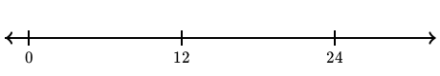
Each pack of hot dog buns contains 9 hot dog buns.
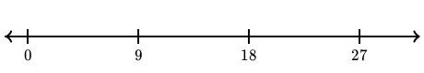

She doesn't have the same amount of hot dogs and hot dog buns yet, she needs to buy more!

When we keep going, we see that the multiples first meet at 36.
Hot dogs
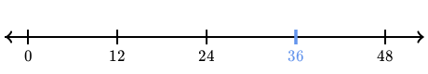
Hot dog buns
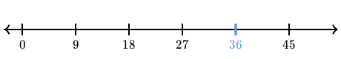
Mathematically, we say that 36 is the least common multiple of 12 and 9. In math notation this looks like: LCM (12, 9) = 36

The smallest total number of hot dogs that Yadira's mom can purchase is 36.

- Let's look at their individual laundry schedules for the next little while.
Ronald does laundry every 6 days.
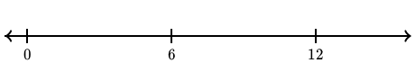
Tim does laundry every 9 days.
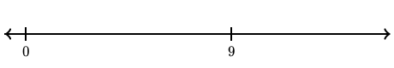
They haven't done laundry on the same day again yet, so let's keep going!
When we keep going, we see that the multiples first meet at 18.
Ronald
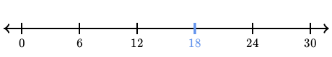
Tim
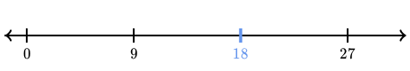
Mathematically, we say that 18 is the least common multiple of 6 and 9. In math notation this looks like: LCM (6, 9) = 18
It will be 18 days until Ronald and Tim both do laundry on the same day again.

- Let's look at the days when Sherman and Brad will each go golfing.
Sherman goes golfing every 6th day.
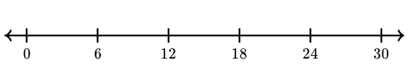
Brad goes golfing every 7th day.
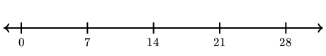
They haven't golfed on the same day again yet, so let's keep going!
When we keep going, we see that the multiples first meet at 42.
Sherman
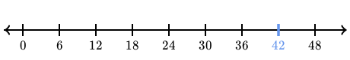
Brad
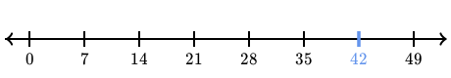
Mathematically, we say that 42 is the least common multiple of 6 and 7. In math notation this looks like: LCM (6, 7) = 42
Sherman and Brad will be golfing on the same day again in 42 days.
- This shape is made up of a big rectangle with a smaller rectangle and a triangle on the side.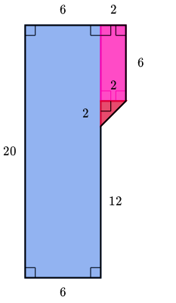
We know the big rectangle is 6 units wide by 20 units high:
Area=6 x 20=120 sq. units
The little rectangle on the side is 6 units by 2 units:
Area=6 x 2=12 sq. units
The triangle is half of a tiny square:
Area=1/2(2 x 2) =2 sq. units
To find the total area of the shape, we can combine the three areas we found:
120+12+2=134
The area of the shape is 134 sq. units.

